**Target: Global Change Biology**

[**https://onlinelibrary.wiley.com/page/journal/13652486/homepage/forauthors.html**](https://onlinelibrary.wiley.com/page/journal/13652486/homepage/forauthors.html)

**Coping with Collapse: Functional Robustness of Coral-Reef Fish Network to Simulated Cascade Extinction**

André L Luza1,2, Mariana G Bender1, Carlos EL Ferreira3, Sergio R Floeter4, Ronaldo B Francini-Filho5, Guilherme O Longo6, Hudson T Pinheiro5, Juan P Quimbayo7,8 Vinicius A G Bastazini9,10

**Affiliation**

1 Department of Ecology and Evolution, Universidade Federal de Santa Maria, Santa Maria, Rio Grande do Sul, Brazil

2 UMR Biodiversité Gènes et Communautés INRAE. Université de Bordeaux, Bât. B2 - Allée Geoffroy St-Hilaire, 33615 Pessac, France

3 Department of Marine Biology, Universidade Federal Fluminense, Niterói, Rio de Janeiro, Brazil

4 Department of Ecology and Zoology, Universidade Federal de Santa Catarina, Florianópolis, Santa Catarina, Brazil

5 Centre for Marine Biology (CEBIMar), Universidade de São Paulo, São Sebastião, São Paulo, Brazil

6 Department of Oceanography and Limnology, Universidade Federal do Rio Grande do Norte, Natal, Rio Grande do Norte, Brazil

7 Department of Evolution, Ecology and Organismal Biology, The Ohio State University

8 Department of Biology, University of Miami, Coral Gables, FL 33146, USA.

9 Mediterranean Institute for Agriculture, Environment and Development (MED), Global Change and Sustainability Institute (CHANGE), Institute for Advanced Studies and Research (IIFA), University of Evora, Evora, Portugal

10 Rui Nabeiro’ Biodiversity Chair, University of Evora, Evora, Portugal

**Corresponding author:** André Luza. [luza.andre@gmail.com](mailto:luza.andre@gmail.com)

**ORCID**

André Luís Luza: 0000-0003-0302-529X

Mariana Bender 0000-0001-5912-5471

Carlos Ferreira: 0000-0002-4311-0491

Sergio Floeter 0000-0002-3143-1474

Ronaldo Francini-Filho 0000-0002-7678-6797

Guilherme Longo 0000-0003-2033-7439

Hudson Pinheiro 0000-0002-3143-1474

Juan P. Quimbayo 0000-0001-5346-3488

Vinicius A. G. Bastazini: 0000-0001-5270-0621

**Funding**

ALL received post-doctoral fellowships from CNPq (#153024/2022-4, #164240/2021-7, #151228/2021-3, #152410/2020-1) and CAPES (PDPG-POSDOC, #88887.800011/2022-00). RBFFi and GOL are grateful to research productivity scholarships provided by CNPq (#309651/2021-2; 308072/2022-7, respectively). We acknowledge funding by the Brazilian Synthesis Institute (Sinbiose, CNPq; grant number #442417/2019-5; PI: M.G.B.), PPBIO IntegraMar (CNPq #441226/2023-0, PI: M.G.B.), and National Funds through FCT – Foundation for Science and Technology under the Project UIDB/05183/2020 (to V.A.G.B).

**Author Contributions Statement**

André Luís Luza - Conceptualization (lead); data curation and formal analysis (lead); Methodology (lead); Writing – original draft (lead); Writing – review and editing (lead).

Mariana Bender - Conceptualization (equal); funding acquisition (lead); Methodology (lead); Writing – original draft (equal); Writing – review and editing (equal).

Carlos Ferreira - Conceptualization (equal); funding acquisition (lead); Writing – original draft (equal); Writing – review and editing (equal).

Sergio Floeter - Conceptualization (equal); funding acquisition (lead); Writing – original draft (equal); Writing – review and editing (equal).

Ronaldo Francini-Filho - Conceptualization (equal); funding acquisition (lead); formal analysis (supporting); Writing – original draft (equal); Writing – review and editing (equal).

Guilherme Longo - Conceptualization (equal); funding acquisition (lead); Writing – original draft (equal); Writing – review and editing (equal).

Hudson Pinheiro - Conceptualization (equal); Writing – original draft (equal); Writing – review and editing (equal).

Juan P. Quimbayo - Conceptualization (equal); formal analysis (supporting); Writing – original draft (equal); Writing – review and editing (equal).

Vinicius A. G. Bastazini - Conceptualization (lead); data curation and formal analysis (lead); Methodology (lead); Writing – original draft (lead); Writing – review and editing (lead).

*In lieu of a cover letter, authors must answer the following questions during submission (max 50 words per answer):*

**What scientific question is addressed in this manuscript?**

We evaluated the resistance of taxonomic and functional facets of reef fish assemblages to cascading extinctions triggered by coral loss. Corals are threatened worldwide due to local and global human impacts, posing severe threats to the intricate network of interactions they support and build reef ecosystems.

**What is/are the key finding(s) that answer this question?**

Our projections for Southwestern Atlantic reefs suggest cascading extinctions could shrink regional functional trait space by 69%, mitigated to 11% by system redundancy and possible rewiring. This highlights the broader impact of coral loss beyond fish-coral interactions, affecting taxonomic and functional diversity facets.

**What are the novel results, ideas, or methods presented in your work?**

Our study represents a significant conceptual advancement in coextinction analysis for two reasons: it evaluates network robustness within a biodiverse, complex, and threatened ecosystem, and it delves deeper than just the taxonomic facet of biodiversity to include a functional perspective.

**Describe how your paper fits within the scope of GCB; What biological AND global change aspects does it address?**

We studied species facing habitat loss, particularly in a vulnerable marine ecosystem prone to cascading extinctions. Reefs, heavily impacted by human pressures, risk collapse, jeopardizing both individual species and ecosystem resilience. Such degradation could trigger cascading effects, culminating in system collapse.

**What are the three most recently published papers that are relevant to this manuscript?**

Doherty, S., Saltré, F., Llewelyn, J., Strona, G., Williams, S. E., & Bradshaw, C. J. A. (2023) Estimating co-extinction threats in terrestrial ecosystems. *Global Change Biology*, 29, 5122–5138. DOI: [10.1111/gcb.16836](https://doi.org/10.1111/gcb.16836)

Luza, A.L., Quimbayo, J.P., Ferreira, C.E.L. et al. (2022) Low functional vulnerability of fish assemblages to coral loss in Southwestern Atlantic marginal reefs. *Scientific Reports,* 12, 17164. DOI: [10.1038/s41598-022-20919-9](https://doi.org/10.1038/s41598-022-20919-9)

Strona, G., Bradshaw, C.J.A. (2022) Coextinctions dominate future vertebrate losses from climate and land use change. *Science Advances*, 8,eabn4345. DOI: 10.1126/sciadv.abn4345

**Conflict of Interest Statement**

We have no conflict of interest to declare.

**Abstract**

Human activities and climate change have accelerated species losses and degradation of ecosystems to unprecedented levels. Both theoretical and empirical evidence suggest that extinction cascades cause a substantial contribution to global species loss. The effects of extinction cascades can ripple across levels of ecological organization, causing not only the secondary loss of taxonomic diversity, but also the erosion of functional diversity. As such, we take a step forward in coextinction analysis by estimating the functional robustness of reef communities to species loss. We built a multilayer network whose nodes and links were built using the output of an assemblage site-occupancy model predicting reef fish occupancy probability (113 species) in function to coral and turf algae cover in the Southwestern Atlantic reefs. This multilayer tripartite network comprised coral species, coral-associated fish (i.e., occupancy directly related to coral cover), and co-occurring fish (i.e. indirectly related to coral cover). We used Attack-Tolerance Curves (ATC) and estimated network robustness (R) to quantify the cascading loss of reef fish taxonomic and functional trait diversity as a response to coral species loss. While functional diversity was robust to the direct loss of coral-associated fish (R=0.85), the taxonomic diversity showed low robustness to coral loss (R=0.54). Both taxonomic and functional diversity showed low robustness to indirect extinctions of fish (R=0.31 and R=0.57, respectively). Projected losses showed that cascading losses could reduce 69% of the regional trait space area, although functional redundancy and possible rewiring could buffer this reduction to 11%, which should not to be overlooked. Our findings indicate that the effects of coral loss in the Southwestern Atlantic reefs go beyond the direct relationship between fish and corals. The ever-growing human impacts on reef ecosystems can cause extinction cascades with detrimental consequences for fish assemblages that benefit from corals.

**Keywords:** cascading extinctions, coextinction, coral-fish association, multilayer ecological networks, species-habitat interactions

**Introduction**

We are facing an unprecedented biodiversity crisis, with species extinction occurring at a much faster rate than those inferred from fossil records (Pimm et al. 2014, Ceballos et al. 2015). Understanding the processes driving species extinction could help us anticipate and mitigate the anthropogenic impacts eroding ecosystems (Ceballos et al. 2015). For example, ecologists have long recognized that the primary loss of species might trigger cascading effects that ripple across ecological communities, through waves of secondary extinctions (e.g., Estes et al. 1998, 2011, Bastazini et al. 2022, Strona & Bradshaw 2022, Doherty et al. 2023). This occurs because species in natural communities are linked to one another based on different kinds of ecological interactions (predator-prey, cleaner-clients, host-parasites, plant-pollinators) forming multi dimensional networks (Estes et al. 2011). Thus coextinctions will likely be common in future ecosystems if we keep the pace of ecosystem exploitation and the broad scale of impacts (Strona & Bradshaw 2022). The extinction of large terrestrial mammals during the Pleistocene resulted in the loss of fundamental ecological interactions, triggering a reorganization of ecological networks and the restructuring of terrestrial ecosystems. This process had far-reaching effects on ecosystem-scale processes such as energy flow and nutrient cycling (Pires 2024). In marine ecosystems, there are notable examples of cascading extinctions following the loss of apex predators on trophic networks (Estes et al. 2011). Despite being under high human-induced threats (Blowes et al. 2019), knowledge on coextinctions in coral and rocky reef ecosystems is still incipient. Reefs hold intricate networks of interactions among species and between species and their habitat (Wilson et al. 2006, Strona et al. 2021, Cantor et al. 2018, Capitani et al. 2022), yielding one of the most diverse and productive ecosystems on the planet (Sheppard et al. 2017). Thus, determining how reef communities will respond to the current environmental crisis is crucial to accurately forecast reef functioning and resilience (Hughes et al. 2018).

Reef fish establish some level/degree of connection with their habitat, that might include the use of reef corals and macroalgae for sheltering, breeding and foraging (Sheppard et al. 2017). Reefs are under threat due to global-scale climate change (Burke et al. 2023, Giglio et al. 2023), and numerous local impacts from unregulated exploration to pollution (Bellwood et al. 2004, Giglio et al. 2023). Recent global estimates of the cumulative effect of these impacts show a striking 36% decline in global-scale coral cover from 1997 to 2018 (Tebbet et al. 2023). Complex reef architecture provides important habitat and refuge for many fish and invertebrates, and the continuing erosion of reef complexity has important consequences for critical reef functions and processes (Alvarez-Filip et al. 2011). The degradation of reef habitats might impair the ecosystem's robustness to extinctions creating cascading effects that could lead the entire system to collapse (Strona & Bradshaw 2022). Despite this scenario, the consequences of coextinction cascades caused by coral loss are virtually unknown.

An useful approach to determine how coral loss can lead to cascading extinctions in reef ecosystems are the widely used "knockout extinction models”, which are simulations of species or area removal aiming to estimate the robustness of ecological networks either formed by intraspecific interactions (Bane et al. 2018) or by species-habitat associations (Evans et al. 2013, Marini et al. 2019). Cascading extinctions were unveiled through multi-taxa species-habitat networks of tropical forests facing deforestation, whereby forest species declined to extinction when deprived from their preferred habitat (Palmeirim et al. 2022). Following the species-habitat approach (Marini et al. 2019), coral reefs are distributed as habitat patches to which species are linked to. While corals are not predominantly distributed in homogeneous patches -- they rather coexist with a heterogeneous number of taxa such as algae, sponges, ascidians (Aued et al. 2018) -- they do constitute critical habitat structures contributing with habitat heterogeneity and resources to reef organisms, most notably to reef fish (Wilson et al. 2006, Coker et al. 2014, Luza et al., 2022, Anderson et al. 2022). The coral-fish association can be so specialized that coral mortality and cover loss causes direct population decline and even local extinction of coral-associated fish (Wilson et al. 2006, Coke et al. 2014). Yet, the strength of this relationship is still debated (recently reviewed by Murunga et al. 2024), and the geographic variations underlying fish sensitivity to coral extinction were recently explored (Parravicini et al. 2014, Strona et al. 2021, Luza et al. 2022). However, the examination of potential cascading effects (indirect extinctions) caused by the loss of corals in tropical reefs, is a topic that remains virtually unexplored to date.

The effects of coextinction cascades can ripple across levels of ecological complexity, causing not only the loss of taxonomic diversity, but also the erosion of functional diversity (Srivastava et al. 2009, Valiente‐Banuet et al. 2015, Bastazini et al. 2022), affecting ecosystem functioning and the provision of services that we depend upon (Giglio et al. 2023). Simulations of global taxonomic and functional loss with coral loss were estimated at 50% for species and 23% for trait combinations (functional entities) for tropical reefs (Strona et al. 2021). However, these analyses excluded Southwestern (SW) Atlantic reefs. For these reefs, 37% of species and 5% functional diversity (regional trait space area) were estimated to decrease with coral loss, implying functional resilience of reef fishes in this province (Luza et al. 2022). Both sets of simulations involved the removal of single coral species, masking the potential influence of cascading extinctions on the structure of reef fish communities. Thus the removal of single species as a direct implication of coral loss can be considered a conservative scenario (Doherty et al. 2023), since climate change will likely affect several coral species at once, with a more harmful impact expected for branching corals (acroporids) and hydrocorals (milleporids) (McWilliam et al. 2018, Hughes et al. 2018). Indeed, these coral groups are those that confer exceptionally high habitat complexity and heterogeneity to reefs. Also, secondary extinctions are likely in this system because fish other than those associated with corals might be related to them through predator-prey relationships (Capitani et al. 2022), facilitation cascades, habitat engineering and mutualistic interactions (Quimbayo et al. 2018).

Here, we take a step forward in coextinction analysis and estimate the functional robustness of reef fish assemblages to coral species loss. We expected to identify fish functional diversity robustness with coral losses, since the range of functions in the assemblage can be maintained through functional redundancy among species. Through the estimation of the proportion of fish species and functions that will persist with coral loss scenarios, we were able to show a limited robustness of the network and ecological trait space to the direct and indirect influence of coral loss, and to illustrate how detrimental coral losses can be to fish assemblages. Such results are particularly useful for informing management and conservation actions, considering the major coral loss scenarios projected over the next 76 years (Hoegh-Goldberg et al. 2007, Freeman et al. 2013, Bleuel et al. 2021).

**Material and Methods**

We used the species-habitat network approach (Marini et al. 2019) coupled with Attack-Tolerance Curves (ATC; Albert & Barabási 2002) and the Reduction in Functional Space approach (RFS, Luza et al. 2022) to quantify the cascading loss of reef fish species and functions as a response to the loss of corals. More specifically we tested the robustness, defined as the area under the ATC (Burgos et al. 2007), of the species-habitat network by building a multilayer network where coral species (the habitat) and reef fish are the network nodes, and the links represent the probability of site occupancy by reef fish in function of coral cover variation (as estimated in Luza et al. 2022). Then we simulated the sequential extinction of corals by their decreasing number of coral-associated fish and used ATCs to show how many species would remain in the network after removals. We used the same attack-tolerance curve to analyze how much trait space area (a multivariate trait space built using six ecological traits of reef fish) would remain with the sequential loss of corals (i.e. the complement of the RFS), and employed a trait-based approach (Mammola & Cardoso 2020) to investigate the consequences of cascading extinctions on trait space area (or functional diversity (FD), Villéger et al. 2008) and occupancy (Carvalho & Cardoso 2020, Mammola & Cardoso 2020).

**Model predictions and the multilayered network**

The multilayered network structure was constructed using data and estimates of a Bayesian community occupancy model produced by Luza et al. (2022). The community occupancy model was used to gauge the relative influence of coral and turf algae cover on 113 reef fish species detected in video plots deployed in 36 sites distributed throughout the Brazilian Province. In essence, these community models are a type of hierarchical model consisting of two interconnected Generalized Linear Mixed Models (GLMMs). These models simultaneously estimate site occupancy probability, denoted as (i.e., the probability that a species *k* will occupy a site *i* based on its environmental conditions, specifically coral and turf algae cover), and detection probability (i.e., the probability of detecting species *k*, on occasion *j* and site *i* where it truly exists) (Kéry & Royle 2016). In this model, the 113 reef fish species were treated as random effects via random slopes and intercepts, ensuring that estimates for all species conform to a common statistical distribution.

Using the model estimates, we classified species into two groups. The “coral-associated fish” group comprised fish positively influenced by coral cover on their site occupancy probability. The relationship between fish species occupancy and coral () and turf cover () was evident in the regression coefficients. Fish species were categorized as 'coral-associated' if were positive and their 95% Credible Intervals of did not overlap zero, and if they exhibited either a neutral (=0) or negative (<0) association with turf algae cover. “Co-occurring fish” were those whose site occupancy probabilities were correlated (at Pearson's correlation coefficient *⍴*≥0.8) with the site occupancy probabilities of coral-associated fish.

Based on this classification, we organized our analysis into three groups: corals (Partite A), coral-associated fish (Partite B), and co-occurring fish (Partite C) within a multilayer network (Fig. 1). The thickness of the links connecting the nodes (species) was determined by predicting site occupancy probabilities based on coral and turf algae cover using the community model. The connections between Partite A and B were established by predicting fish site occupancy probabilities based on coral cover while holding turf algae cover constant. To make these predictions, we utilized the model's intercept and regression coefficients to estimate site occupancy probabilities at four standard deviations from the mean coral cover (which translates to approximately 10% cover for more abundant corals like *Siderastrea* spp. and *Millepora alcicornis*, and around 1% cover for less abundant species such as *Agaricia* spp., *Porites astreoides*, and *Favia gravida*) and zero standard deviations from the mean for turf algae cover (about 18% cover). In essence, this yielded one value per fish species (out of a total of 113 species, although only estimates for coral-associated fish were used) that represented the expected proportion of sites occupied by each fish species given the coral cover. We used these estimates to establish the links between Partite A and B.

To establish the links between Partite B and C, we computed the Pearson’s correlation coefficient (*⍴*) between site occupancy probabilities for each coral-associated fish (42 species) and the remaining species (71 species) at the site level (n=36 sites). We then applied a correlation threshold of *⍴*≥0.8 to define co-occurring species. In total, 21 species met this criterion. This correlation information was used to establish the thickness of the links between Partite B and C. We tested whether species from the partite C belonged to higher trophic levels and had larger body sizes than species in the partite B using ANOVA.

**The order of extinctions, attack-tolerance curves, and robustness analyses**

We used the multilayer network and a trait-based approach to simulate and evaluate the direct and indirect effects of coral loss to reef fish communities. Robustness (*R*) was estimated based on the area below the attack-tolerance curves (ATC; Albert and Barabási 2002, Burgos et al. 2007), a metric that represents how much the network maintains its structure under attack (i.e., extinctions). *R* values range from 0 to 1, with 1 indicating highest network robustness, i.e., the functional trait space is the most tolerant to coral removal. We simulated species extinctions in the network and evaluated direct and indirect effects using the following algorithm:

1. Let G be the bipartite network with two sets of nodes (A) corals and (B) coral-associated fish, or B and (C) co-occurring fish, in which the links between nodes are defined by species site occupancy probability or co-occurrence, respectively;
2. Let f(B|A) be the function to estimate functional diversity for species in the set (B) given losses in the set (A), and f(C|B) in the set (C) given the losses in the set (B). RFS is the Reduction in Functional Space metric from Luza et al. (2022), and FD is Functional Diversity (measured through the convex-hull area of a multidimensional space built from traits, Villéger et al. 2008):
   1. f(B|A) = RFS = FDt=1 / FDt=0
   2. f(C|B) = RFS = FDt=1 / FDt=0;
3. Set t = 0 to represent the current time step (no extinction).

While there are nodes remaining in the partite A (t < | A):

1. Select a species *k* in the partite A, based on its degree centrality, and remove it from the network G at time *t*. Do the removal in descending order;
2. Update the whole multilayer network, also removing the links associated with the species *k*: Gt=1 <- G - {*k*};
3. Estimate taxonomic (number of species) and functional diversity for species in the partite B and C (f(B|A) and f(C|B));
4. Add the value of f(B|A) and f(C|B) to the cumulative sum area: area t=1 <- area + f(B|A) or f(C|B);
5. Increment the time step up to the number of species in the partite A: t <- t+1. The algorithm then ends when all species from the partite A have been removed from the network.

Coral species removal/ loss in partite A followed a decreasing order of coral degree centrality (number of links between each coral and fish species). Therefore, coral with the largest number of associated fish were the first to be eliminated, and so on. To simulate extinctions, we worked in parallel in the two bipartite networks. Operationally, the networks were worked as matrices, **XC-CAF** and **XCAF-COF**, which represented the consequences of losing nodes in partite A to the partite B and C, respectively. In the first matrix **XC-CAF**, comprising corals (**C,** rows) and coral-associated fish (**CAF,** columns), one coral-associated fish could be eliminated after the elimination of the coral *k* in time step *t* if its column values sum to zero (i.e., no positive site occupancy probability remains). Then, in the other matrix **XCAF-COF** , one co-occurring fish (**COF,** columns) could have its elimination triggered by the loss of one coral-associated fish (**CAF,** rows)in the time step *t* if its column values sum to zero (i.e., no positive correlation between site occupancy probabilities of these fish remaining in the matrix).

The taxonomic diversity was measured as the number of columns (fish species) of each matrix in each time step, relative to the total number of columns in the time step *t=0*. As with the taxonomic counterpart, our functional ATC is constrained in the unit square and starts at a value 1 in the *y*-axis, when there is no loss of area with coral loss and the entire fish functional space is intact. As coral species are removed, the curve decreases monotonically to 1 in the *x*-axis as the functional space decreases because all corals have been lost.

**Trait space area (functional diversity) and occupancy**

We used a trait-based approach to link the direct (loss of coral-associated fish) and indirect effects (loss of fish co-occurring with coral-associated fish) of coral loss on the functional structure of reef fish assemblages. The trait-based approach considers the relationship between species and traits to produce a measurement of diversity (the trait space area) (Villéger et al. 2008) and frequency/density (occupancy) of ecological strategies and functions (Mammola & Cardoso 2020). To evaluate functional robustness to cascading extinctions, we used the Reduction in Functional Space approach (RFS, cf. Luza et al. 2022) to quantify the reduction in the trait space area of coral-associated + co-occurring fish (trait space area considering 63 species) along simulated coral losses. For robustness and RFS analyses, the trait space was built for coral-associated + co-occurring fish (63 species). For trait space occupancy analysis, a Provincial trait space (n=113 species) was built and, based on it, subsequent spaces (polygons) were built for the following set of species:

1) coral-associated fish (n=42);

2) coral-associated + co-occurring fish (n=63 species);

3) all fish except coral-associated + co-occurring (n=50);

4) vulnerable species (n=5), based on IUCN status and price value (data from Quimbayo et al. 2021).

We built trait spaces using six ecological traits: total length (cm), trophic level (the position in the food web, unitless), fin aspect ratio (unitless), group size (categories from solitary to large sized groups), maximum tolerated temperature (TºC) and depth (m). The correlation of each trait with each PCoA axis was calculated through the Pearson’s regression coefficient, and projected in the trait space to improve interpretation. All traits, except for total body length that was obtained directly from the video estimates (Longo et al. 2019), were gathered from Quimbayo et al. (2021). Total body length, aspect ratio, trophic level, maximum preferred temperature and depth were treated as quantitative traits, whereas group size was treated as an ordered trait (schooling fishes had higher ranks than solitary fishes). Functional trait space area was calculated through the convex-hull approach of Cornwell et al. (2006) and Villegér et al. (2008). We performed a Principal Coordinate Analysis (PCoA) to project, in a quasi-Euclidean multidimensional space, the matrix of trait dissimilarities (Gower distance applied to scaled trait values, using the daisy function of the ‘cluster’ R package, Maechler et al. 2022) between pairs of species, using the dudi.pco function (‘ade4’ R package, Dray & Dufour 2007).

Trait space occupancy (density) was estimated by applying a Kernel Density Estimation (KDE) (Duong 2007) to the eigenvectors of the two first PCoA axes, which revealed areas of high and low species density in the trait space. We estimated the KDEs for each period using the kde R function (‘ks’ R package), and produced plots using the ‘ggplot2’ R package, Wickham 2016). We used unconstrained bandwidth selectors for building the KDE, once the results depend on the choice of bandwidth used for smoothing kernels (Duong 2007). The selected bandwidths were 0.5, 0.9, and 0.99 quantiles, representing 50%, 90%, and 99% probability of species occupancy in different portions/zones of the trait space. Finally, we used histograms (plotted along the PCoA axes) to depict the density of species in the PCoA area. All analyses were run in the R programming environment (R Core Team 2024).

**Results**

The probability of site occupancy of 56% of the species (*n*=63 out of 113 reef fish species) had both direct and indirect relationship with coral cover. Overall, 37% (*n*=42) were coral-associated fish (Partite B, Fig. 1) and 19% (*n*=21) were co-occurring fish (Partite C, Fig. 1). Species from the partite C belonged to higher trophic levels than species in the partite B (β=0.58, F1,61= 7.66, P=0.007) (Fig. 2). There were no differences in body size between partities (Fig. 2). The coral-associated fish establishing links with more coral species were *Acanthurus coeruleus*, *Sparisoma axillare*, and *Scarus zelindae* (Fig. 1, partite B). Co-occurring fish establishing more links with coral-associated fish were *Lutjanus analis*, *Amblycirrhitus pinos*, and *Sphyraena barracuda* (Fig. 1, partite C).

Fish functional diversity showed greater robustness (*R*) to coral loss compared to taxonomic diversity. Despite the removal of corals and 42 fish species directly associated with them, the functional diversity of the fish assemblage remained robust in the face of the direct loss of corals (*R*=0.85), whereas the taxonomic diversity showed low robustness to coral loss (*R*=0.54). Additionally, the removal of corals and 63 fish species directly and indirectly related to corals resulted in both taxonomic and functional diversity showing limited robustness to coral loss (*R*=0.31 and *R*=0.57, respectively) (Fig. 3).

Our findings suggest that coral loss has the potential to decrease the trait area of fish assemblages at the province scale by 69% (Fig. 4A). However, this estimation does not fully consider the trait redundancy observed between coral-associated and co-occurring fish species (n=63) and the remaining fish species (n=50). Specifically, coral-associated and co-occurring fish occupy 69% of the provincial trait space area, while the remaining fish occupy 87% of this area, with a significant overlap (illustrated by the light gray polygon in Fig. 4A). An area of 11% of the provincial trait space area is exclusively occupied by coral-associated and co-occurring fish. This redundancy between removed and remaining species may partially alleviate the loss of functional diversity caused by cascading extinctions from coral-associated to co-occurring fish, despite significant declines in taxonomic diversity.

Furthermore, our results also show that 43% of the provincial trait space is occupied by species that are vulnerable to extinction, including *Epinephelus marginatus*, *Lutjanus cyanopterus*, *Mycteroperca interstitialis*, *Rhomboplites aurorubens*, and *Scarus trispinosus* (which is also a coral-associated fish). Notably, these species are situated in peripheral areas of the trait space occupied by few species (Fig. 4A).

In addition to the effects on trait space area (FD), cascading extinctions lead to less densely filled trait spaces (Fig. 4-B3). There is a high concentration of species in the core of the trait space (hot colors, Fig. 4-B3). The direct and indirect effects of coral loss affected species distributed within and along the edge of this core, resulting in lower functional variation among species (as shown by the marginal histograms). Regarding the traits per se (Fig. 4A), coral loss would directly affect species belonging to low trophic levels, with both small and large body sizes, occupying shallow and warm waters, and with small group sizes and aspect ratios (red areas in Fig. 4-B1). While also affecting species in similar trait space zones, the indirect effect additionally influenced species with large body sizes and aspect ratios (red areas in Fig. 4-B2).

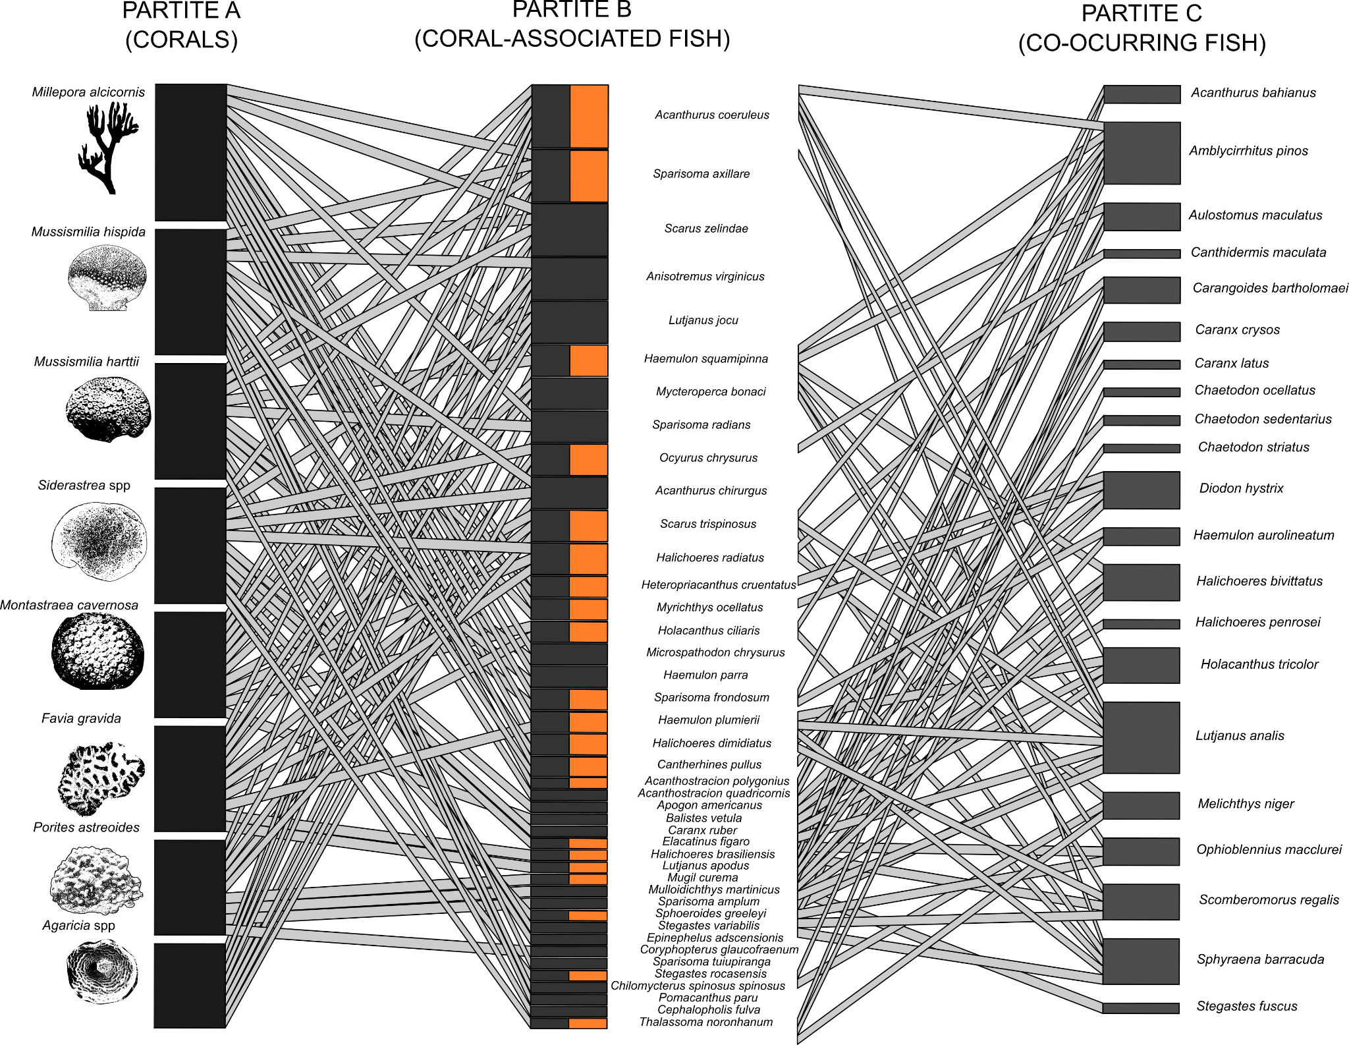

*Fig. 1 - Multilayer network showing a habitat-species-species network. In this network, the habitat is characterized by the cover of scleractinian corals and hydrocorals (left part). The network is organized according to the decreasing number of fish species associated with different corals. The width of the links in the left network depicts the predicted site occupancy probability by fish species (*) *as a function of coral cover (while maintaining turf algae cover constant), and in the right part the width of the links depicts the correlation between the site occupancy probability of coral associated fish and other fish. The height of black bars in Partite A depict the number of fish associated with each coral species. The height of gray bars in Partite B depict the number of corals that each fish was associated with, and the height of bars in Partite C show the number of coral-associated fish that each co-occurring fish was associated with. The orange bars in the partite B highlight coral-associated fish that establish relationships with co-occurring fish (only pairwise correlations higher than ρ*≥*0.8 were projected in the figure and used in data analysis).*

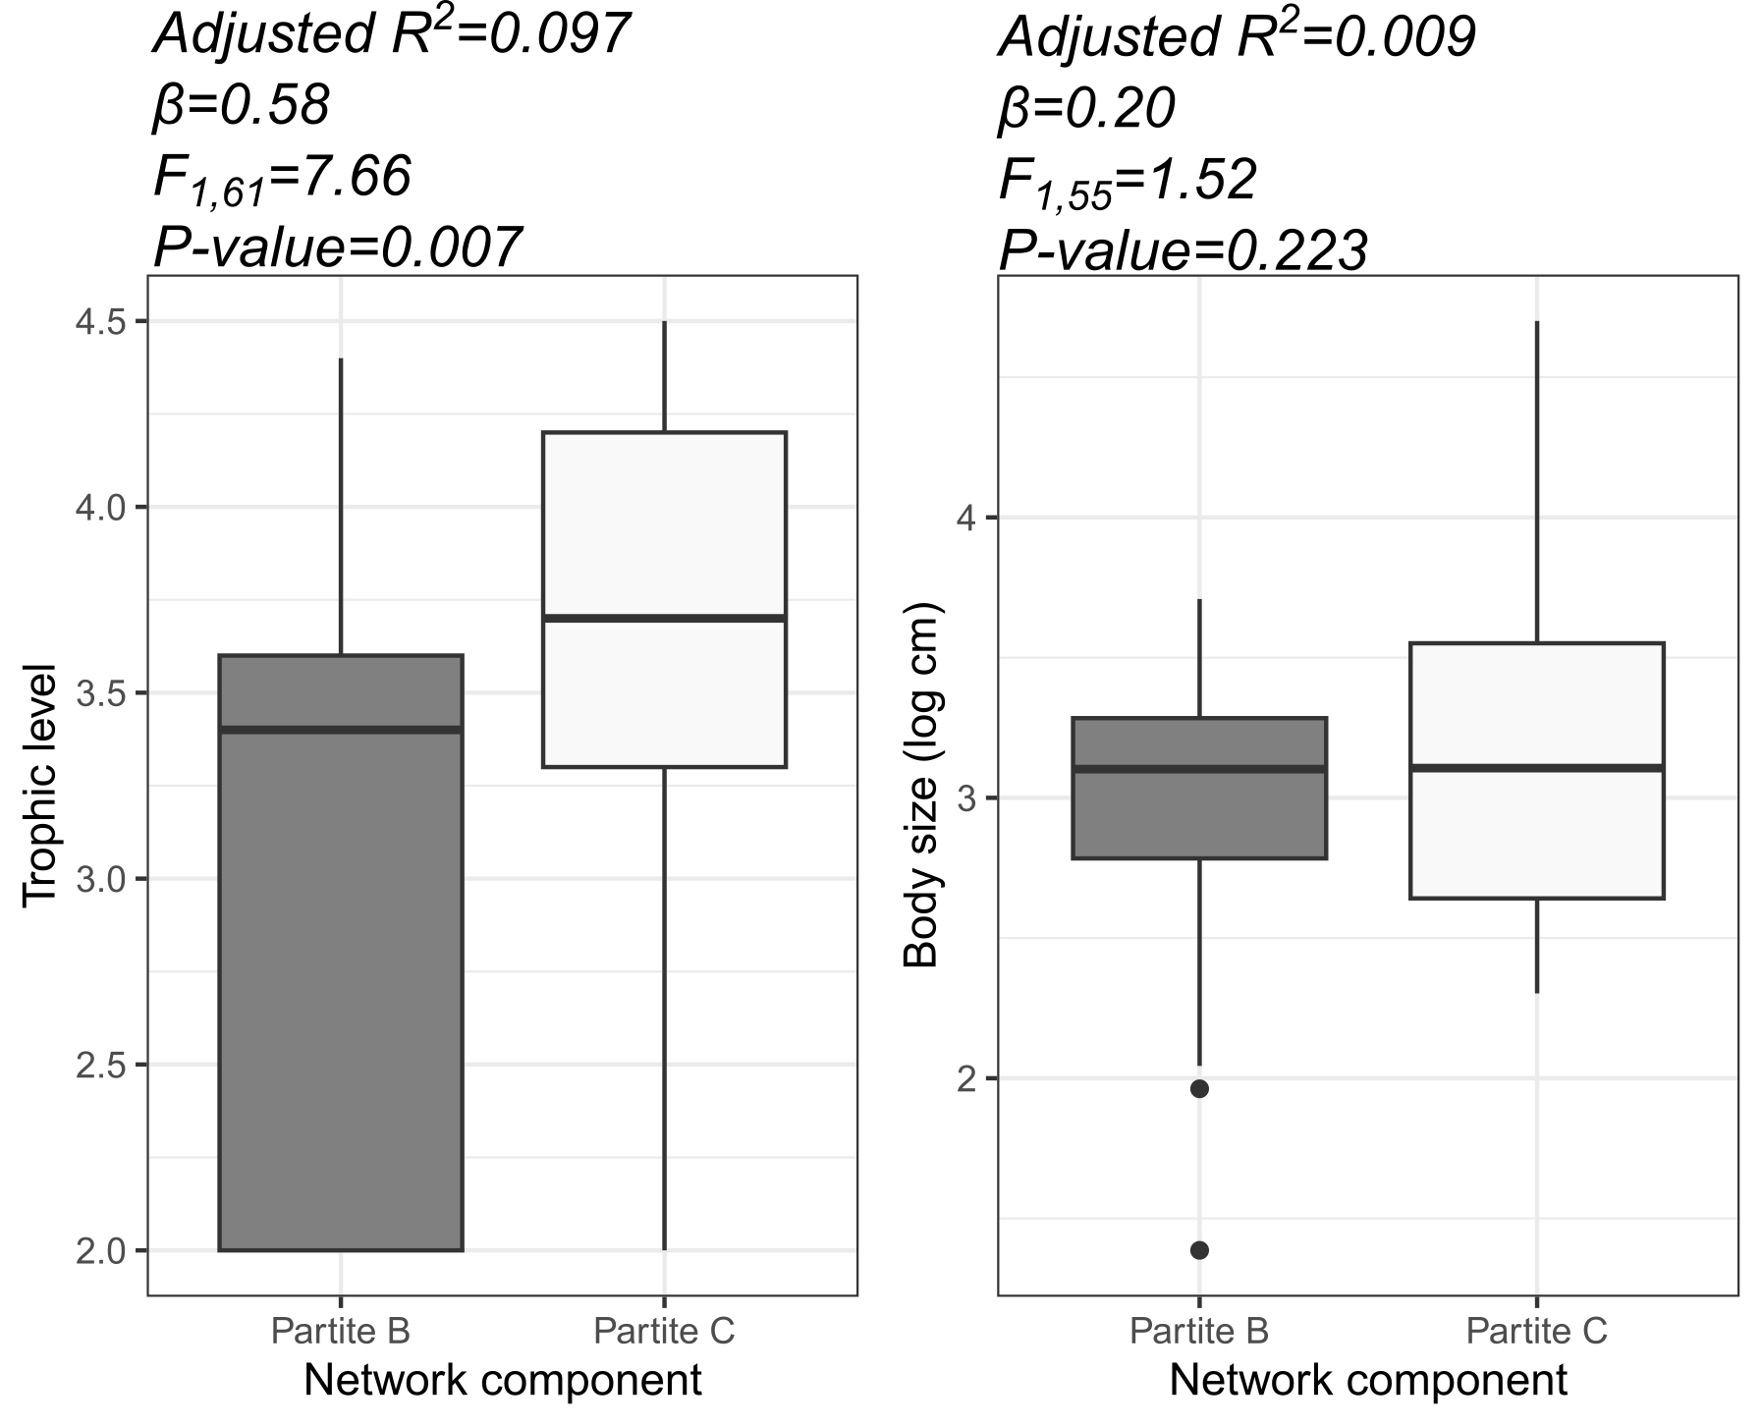

*Fig. 2: Variation of trophic level (A) and body size (B) between reef fish species in partite B (coral-associated fish) and C (co occurring fish).*

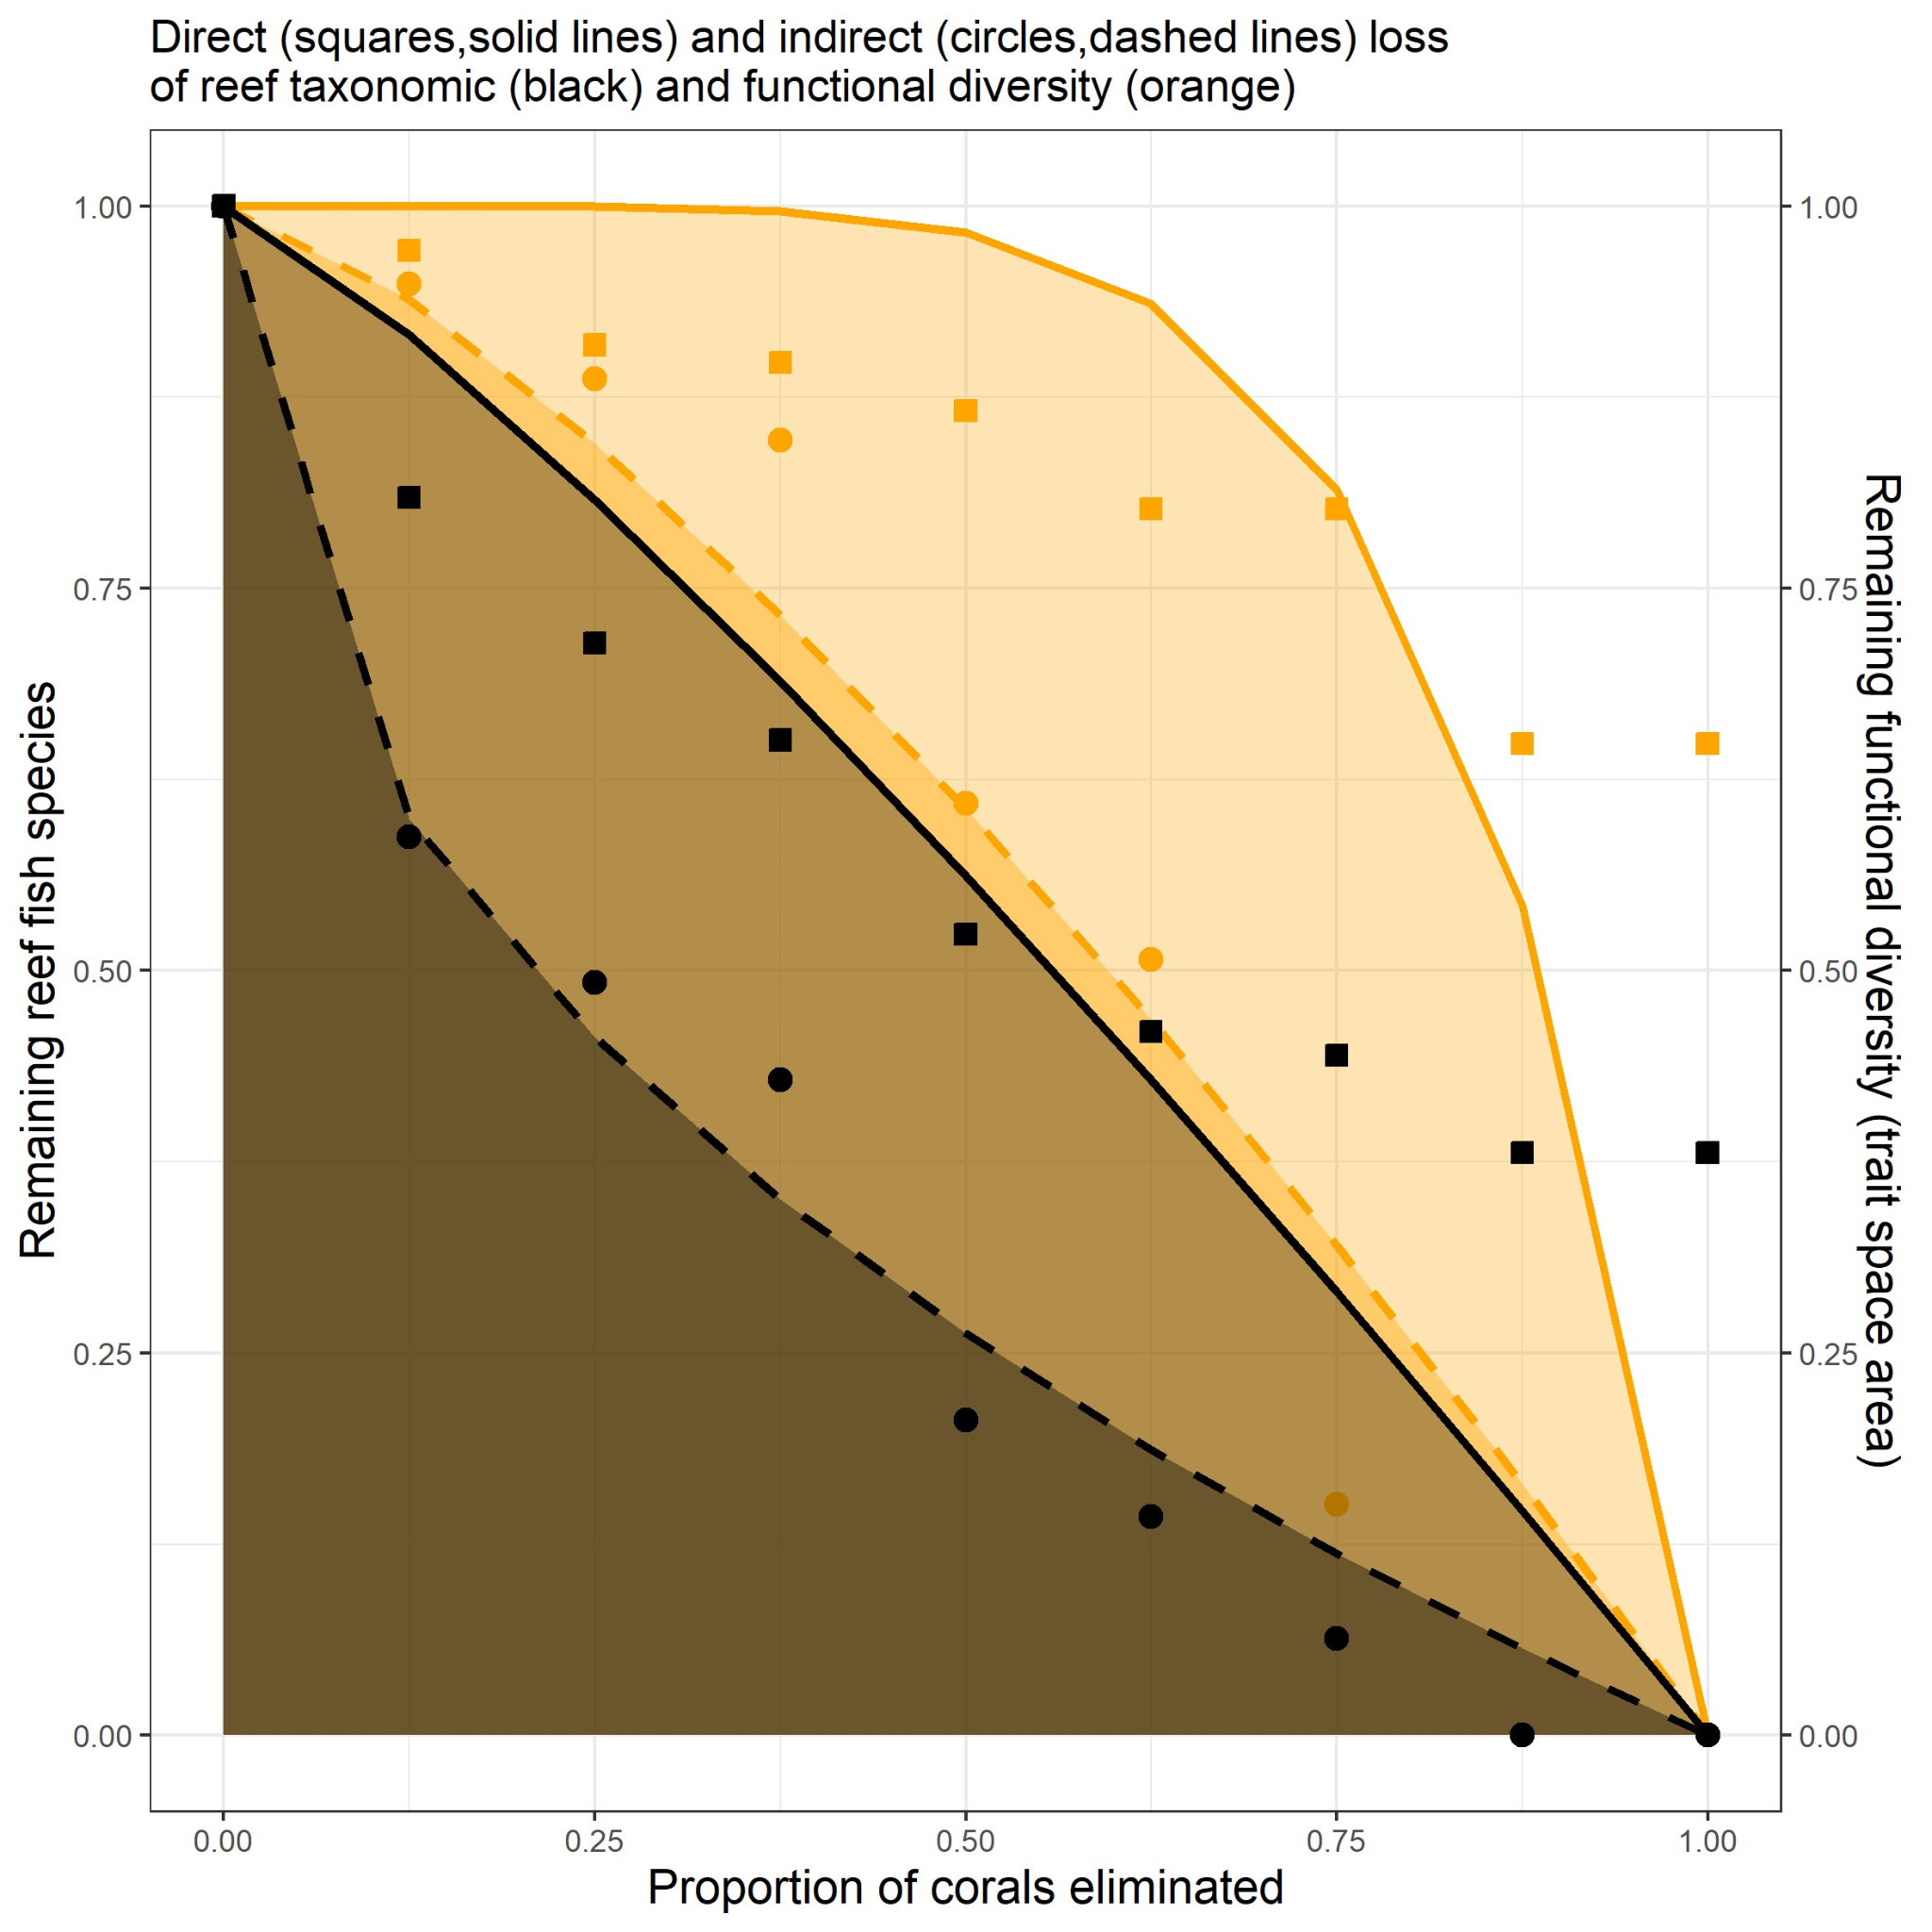

*Fig. 3 - Attack Tolerance Curves (ATC) depicting direct and indirect effects of coral loss on fish taxonomic and functional diversity. The shaded area below each curve depicts the hyperbolic/cubic model fitted to the data shown in the two Y-axes. Direct effects comprise the loss of fish taxonomic and functional diversity caused by coral loss. Indirect effects comprise extinctions of fish whose number of occupied sites (sum of the parameter* *across species) was correlated with the number of sites occupied by coral-associated fish.*

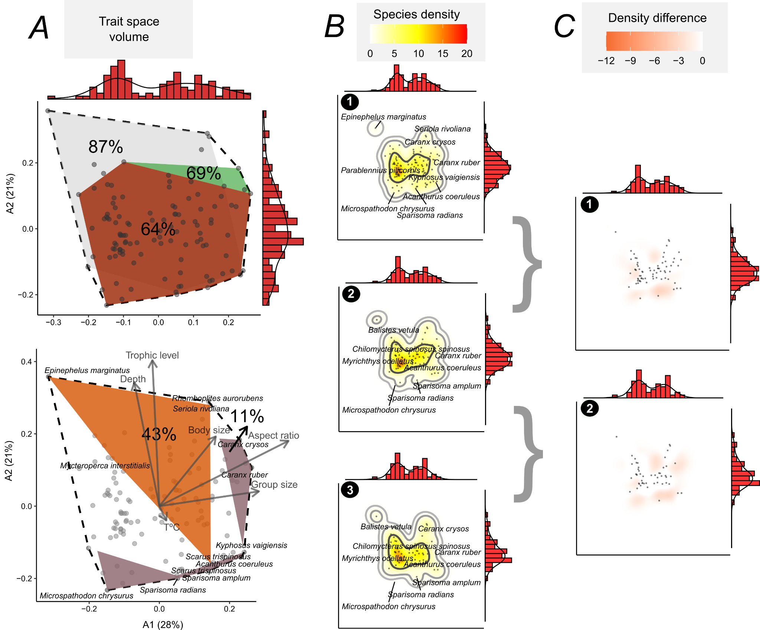

*Fig. 4 - Trait space occupancy by reef fish in the Brazilian Province. At the top of* ***A*** *we show the trait spaces of the Brazilian Province fish (n=113 species, white polygon with black dashed line), coral-associated fish (n=42, dark red polygon, trait space volume: 64%), coral-associated + co occurring fish (n=63 species, green polygon, volume: 69%), remaining species (n=50, inner light gray polygon, volume: 87%). At the bottom of* ***A*** *we show the correlation of each trait with the two first ordination axes, and the polygons of threatened species (orange polygon, volume: 43%) and the area vulnerable to cascading extinctions (purple, volume: 11%). In* ***B*** *we show trait space occupancy within the Provincial trait space (1), and the trait space occupancy after simulating the direct (2) and indirect effects of losing corals (3). The density (trait space occupancy) was produced by a kernel density estimation algorithm, with contours depicting 50%, 95%, and 99% kernel density bands. In* ***C****, we show the difference in trait space occupancy after simulating the direct (1) and indirect effects of losing coral species (2). The marginal histograms (with density shown) of all plots depict the concentration of points (species) in the trait spaces. The trait space was produced by summarizing trait data with a Principal Coordinate Analysis (PCoA), and the variation explained by these axes are presented in the first plot (A).*

**Discussion**

Coextinctions are difficult to observe in nature as they are hard to detect or take time to happen (Estes et al. 2011). Using simulations of cascading effects of coral loss on fish, we evaluated the taxonomic and functional robustness of coral-reef fish multilayer network to extinctions. The species-habitat multi-layered network approach coupled with Attack-Tolerance Curves (ATC) revealed cascading loss of reef fish species and functions as a response to coral loss in Southwestern Atlantic reefs. Our analysis of co-extinctions can represent a more realistic and applied scenario in terms of conservation than our previous results reported in Luza et al (2022), which were based on a more conservative scenario of direct extinction of coral-associated fishes.

Reefs comprise the most biodiverse and threatened marine ecosystem, and much of their biodiversity is due to the central role that corals play in building tridimensional reef habitats that support diverse communities of other organisms (Wilson et al. 2006, McWilliam et al. 2018, Woodhead et al. 2019). Coral survival and persistence in the Anthropocene is uncertain (Freeman et al. 2013, Bleuel et al. 2021), posing threats to the complex network of species relying on corals (Bellwood et al. 2004, Woodhead et al. 2019, Strona et al. 2021, Tebbet et al. 2023). Cascading loss of reef fish species and functions as a response to coral loss in Southwestern Atlantic reefs revealed by the Attack-Tolerance Curves (ATC) suggests a concerning scenario. Southwestern Atlantic reefs are overlooked marginal reefs, characterized by low coral cover (Kleypas et al. 1999, Aued et al. 2018, Schoepf et al. 2023), and are typically excluded from discussions and analyses addressing biodiversity loss resulting from coral decline (Giglio et al. 2023). This fact can have multiple causes, including the lower diversity of corals and fish when compared to coral reefs found in other biogeographic regions, and the generalist relationships between corals and fish in the region. Despite this, the loss of habitat patches with low overall coverage can have a disproportionate impact on ecological networks, as shown in other systems such as plant-insect networks in farmlands (Evans et al. 2013). The shape of the ATC curves, with steep declines in taxonomic diversity (for direct and indirect scenarios) and functional diversity (only the indirect scenario), depict two interesting aspects concerning the robustness of this multilayer network.

Initially, fish assemblages demonstrate the ability to sustain functions even in the face of direct losses of coral-associated fish. This finding reinforces the notion of functional resistance of coral-associated fish networks to direct losses, as initially expected. Coral-associated fish may exhibit a limited and generalized reliance on coral habitats (Wismer et al. 2019, Murunga et al. 2024), showcasing redundancy in their ecological traits (Luza et al. 2022) and functions (Brandl et al. 2019). Theoretically, such low specificity in the associations/interactions between corals and fish might prevent co-extinctions (Brodie et al. 2014). Therefore, the loss of a single species does not necessarily impair the delivery of a particular function (or the presence of certain combinations of fish traits in reef sites). Alternatively, fish may display extinction debt, with the potential for relationships to weaken and species, as well as their functions, to be lost over time (Anderson et al. 2022). These characteristics endow the network with resilience and confer, at least in the short term, robustness to reef ecosystems, enhancing resistance to the loss of critical functions. The functional redundancy among reef fish species and low vulnerability in assemblages (species correspond to unique functional entities) might buffer the loss of ecological functions following the loss of fish taxonomic diversity (or species) from coral loss.

Our comprehensive analysis of the multilayer network, including both direct and indirect links with corals, revealed a concerning low robustness of fish assemblages in the Brazilian Province. The loss of corals has a profound impact on the network structure, with indirect losses proving to be even more detrimental to the fish assemblage than direct ones. Remarkably, the influence of coral cover loss extends beyond mere taxonomic diversity, affecting even those fish indirectly related to coral cover. We attribute this to two key factors: firstly, most fish with a higher likelihood of inhabiting areas with high coral cover often display a set of ecological traits (e.g., small body size, low trophic level, small group size) that are well distributed in the assemblage and not taxonomically constrained. These traits define a resilient core group of species within the trait space (i.e. functionally redundant) that remains relatively stable with the propagation of disturbances (here imposed by simulations); secondly, this core group play essential roles in forging vital links, connecting peripheral fish within the network, with species having a more restricted set of traits (few species sharing similar combinations) which then become susceptible to coral loss. As such, these core species that interact with vulnerable links are themselves theoretically susceptible to exhibit declines (Brodie et al. 2014). This dual function of coral-associated fish is crucial for maintaining ecosystem integrity, bridging benthic community-level processes (like carbon accretion and prey populations control) with broader nutrient cycling facilitated by mobile organisms (Brandl et al. 2019).

We observed that the low estimated robustness to coral loss signals a potential threat to ecosystem functioning. It is important to recognize that direct and indirect drivers of environmental change do not act in isolation; rather, they interact, creating synergies and antagonisms (Ruiz et al. 2021, Soares et al. 2021, Giglio et al. 2023). For example, ocean warming and acidification can lead to significant coral mortality through bleaching events (Sully et al. 2019, Tebbet et al. 2023). In conjunction with overfishing, they can adversely affect fish populations by altering habitat structures and the abiotic environment, as well as trait composition within an assemblage (Silva et al. 2023). These synergistic stressors can destabilize the trophic structure of ecological communities, exerting intense pressure on species that play a disproportionate role in maintaining network structure. This impact is observed in both land (Vidal et al. 2014) and marine networks (Márquez-Velásquez et al. 2021, Bascompte et al. 2005). A case in point comprises the Tropical Eastern Pacific food webs (coast of Colombia), where key species such as the hammerhead shark (*Sphyrna* spp.), which faces a high extinction risk and interacts with small-scale fisheries, have a significant impact on the network structure (Márquez-Velásquez et al. 2021). Similarly, in the Caribbean, sharks and groupers, both threatened by fisheries, engage in the strongest interactions within food webs (Bascompte et al. 2005). While distinct from food webs, the species-habitat network approach is a valuable tool in identifying vulnerable links within the ecosystem, as it allows us to estimate the importance of habitat patches to the maintenance of local and regional biodiversity (Marini et al., 2019).

In the Southwestern Atlantic reefs, species like the endemic and endangered greenbeak parrotfish (*Scarus trispinosus*), the near-threatened yellowtail snapper (*Ocyurus chrysurus*) and the mutton snapper (*Lutjanus analis*),and the black grouper (*Mycteroperca bonaci*), fulfill crucial ecological roles and occupy regions of the trait space with low species density. Serving as major biomass consumers, they actively circulate nutrients and materials throughout the ecosystem. The former species, which feeds on turfs and endolithic algae on the reef matrix, and the two latter species, which primarily feed on vertebrates and invertebrates, show increased site occupancy (and likely greater abundance) with greater coral cover (Moura et al. 2013, Roos et al. 2019, Luza et al. 2022). Furthermore, these species are heavily targeted by fisheries in Brazil and present population declines across their geographical range (Roos et al. 2019, Eggertsen et al. 2024). Their extinction, severing links between corals and co-occurring fish, could affect coral health and reef structure (McCook et al. 2001), while potentially easing competition for smaller predators and removing a vital food source for larger ones. This suggests that the redundancy within the system, concentrated in the densely populated core of the trait space, may not suffice to sustain ecosystem functionality if these at-risk network nodes are lost. This is particularly concerning given the synergistic threats posed by coral loss, overfishing, and climate change, which exacerbate the situation.

In evaluating network robustness, we relied on broad generalizations. First, the primary dataset was designed to elucidate feeding interactions between reef fish and benthic organisms (Longo et al. 2019, Inagaki et al. 2020), which may not fully capture the nuances of fish-to-fish interactions (but see Fontoura et al. 2020). Similarly, pairwise correlations of site occupancy probability between species may not capture fish-to-fish relationships. Relying on these correlations demand cautious interpretation (reviewed by Blanchet et al. 2020) even in species-habitat networks. For instance, two species may be linked because they prefer/avoid the same factor not included in the model (i.e., beyond coral and turf cover, such as temperature, pollution), and/or be interacting with other species present in the system (Blanchet et al. 2020). However, we lack data to measure the relevance of these caveats.

We revealed processes at the regional scale, integrating data from various species and sites across the entire Brazilian marine biogeographical province. At this scale, extinctions are expected to be less frequent, as some populations of threatened species can persist locally. This means that a function might persist regionally, albeit in a significantly reduced capacity (i.e. functional extinction, Brodie et al. 2014, Valiente-Banuet et al. 2015). As the goal here was to evaluate robustness and present a new algorithm for functional robustness evaluation, the possibility of adaptive rewiring (i.e., interaction partner switch through time) was not accounted for. The ability of species to adapt to the absence of the interaction, or even interact with a different habitat or species, is an important component of the resistance to cascading extinctions (Brodie et al. 2014, Vizentin-Bugoni et al. 2020). Indeed, the majority of fishes inhabiting the Brazilian Province tropical and subtropical reefs, besides being broadly distributed (Pinheiro et al. 2018), have a large degree of trophic generalism (Liedke et al. 2016, Cardozo-Ferreira et al. 2023). Further examination of rewiring potential is warranted, as many species not associated with corals persist in the system following simulated extinctions. Hence, we emphasize that the 11% reduction should not be disregarded, as it assumes that the remaining species will fulfill similar interactions and ecological functions as those directly and indirectly impacted by coral removal. But since we still don't fully understand the mechanisms underlying ecological networks' reorganization in response to species loss (Bastazini et al. 2019), our approach provides a useful and conservative scenario, ignoring species rewiring. Future developments in our understanding of the nature of ecological interactions and the driving mechanisms of network reorganization in coral systems will certainly improve our ability to forecast the effects of species loss and provide more accurate scenarios of network robustness and resilience in a changing environment.

Despite such generalizations, our inference about species-habitat links derives from fine-scale resolution and the close matching of fish and coral sampling (Aued et al. 2018, Longo et al. 2019), a positive point emphasized by Blanchet et al. (2020). These insights underscore the necessity for future research with sampling designs tailored to detect multi-level interactions (Bascompte et al. 2005, Márquez-Velásquez et al. 2021), and emphasize the importance of local-scale assessments of species-habitat networks.

**Concluding Remarks**

Tropical and subtropical reefs of the Brazilian Province are nominally marginal compared to the nearby Caribbean, with different evolutionary histories (Pinheiro et al. 2018), and with environmental conditions considered suboptimal for most tropical coral species (Schoepf et al. 2023), including high turbidity and nutrient-rich waters (Mies et al. 2020, Santana et al. 2023). These reefs hold a relatively species-poor coral fauna with low redundancy, which makes coral-fish associations less obvious when compared to the Great Caribbean and for the Indo-Pacific realm, but still existent (Coni et al. 2013, Luza et al. 2023). Despite offering numerous functions and ecosystem services, Brazilian reef environments are increasingly under the strain of escalating anthropogenic pressures at various scales (Soares et al. 2021). Here we detected a limited ability of reef fish assemblages to endure one of the main changes of the Anthropocene: the possible loss of corals. We observed higher levels of robustness to direct species loss, yet the indirect effects of coral loss on the species-habitat network structure were significant when considering indirect links between corals and fish. Such coral loss stems from both global factors, like warming, and local impacts, including pollution and overfishing of herbivores (Tebbet et al. 2023). Coral-associated fishes exhibit a resilient functional structure in healthy reefs, potentially due to adaptation to marginal conditions (Wismer et al. 2019). However, it remains an open question whether this resilience holds in scenarios where coral loss is driven by anthropogenic impacts. Human influence in the Brazilian province has been long-standing (Fogliarini et al. 2022, Eggertsen et al. 2024), and there is scant historical data on what may have already been lost (Castro & Pires 2001, Fogliarini et al. 2022). Furthermore, many coral-associated and co-occurring fishes are also directly affected by overfishing or aquarium trade (Gasparini et al. 2005, Carvalho et al. 2022). This combination of factors can lead to additive effects, potentially setting off a cycle of extinction capable of eroding critical ecological processes mediated by unique species and function entities. Our study represents a significant conceptual advancement in coextinction analysis for two reasons: it evaluates network robustness within a biodiverse, complex, and threatened ecosystem, and it delves deeper than just the taxonomic facet of biodiversity to include a functional perspective. Overall, ecological networks offer a rich theoretical and empirical basis for grappling with the complex implications of the Anthropocene crisis.

**Data availability statement**

This project is on GitHub: <https://github.com/andreluza/species_habitat_interactions.git>. Basic data supporting analyses will be made public after the acceptance of the manuscript.

**References**

Albert, R., Barabási, A-L. (2002) Statistical mechanics of complex networks. Review of Modern Physics 74.

Alvarez-Filip, L., Gill, J. A. & Dulvy, N. K. (2011) Complex reef architecture supports more small-bodied fishes and longer food chains on Caribbean reefs. Ecosphere 2, 118. <https://doi.org/10.1890/ES11-00185.1>.

Anderson L, McLean M, Houk P, Graham C and others (2022) Decoupling linked coral and fish trait structure. Marine Ecology Progress Series 689:19-32. https://doi.org/10.3354/meps14023

Aued, A. W. et al. (2018). Large-scale patterns of benthic marine communities in the Brazilian Province. PLoS ONE 13, e0198452. https://doi.org/10.1371/journal.pone.0198452 (2018).

Bane MS, Pocock MJO, James R. (2018) Effects of model choice, network structure, and interaction strengths on knockout extinction models of ecological robustness. Ecology and Evolution 8, 10794–10804. <https://doi.org/10.1002/ece3.4529>

Bascompte J, Melián CJ, Sala E. (2005) Interaction strength combinations and the overfishing of a marine food web. Proceedings of the National Academy of Sciences of the United States of America. 102(15), 5443-7. doi: 10.1073/pnas.0501562102.

Bastazini, V. A., Debastiani, V. J., Azambuja, B. O., Guimarães, P. R., & Pillar, V. D. (2019). Loss of generalist plant species and functional diversity decreases the robustness of a seed dispersal network. Environmental Conservation, 46(1), 52-58.

Bastazini, V.A.G., Debastiani, V., Cappelatti, L., Guimarães J., P., Pillar, V.D. (2022) The role of evolutionary modes for trait-based cascades in mutualistic networks. Ecological Modelling, 470, 109983. https://doi.org/10.1016/j.ecolmodel.2022.109983

Bellwood, D., Hughes, T., Folke, C. et al. (2004) Confronting the coral reef crisis. Nature 429, 827–833. <https://doi.org/10.1038/nature02691>

Blanchet FG, Cazelles K, Gravel D. (2020) Co-occurrence is not evidence of ecological interactions. Ecology Letters 23(7), 1050-1063. doi: 10.1111/ele.13525.

Bleuel, J., Pennino, M.G. & Longo, G.O. (2021) Coral distribution and bleaching vulnerability areas in Southwestern Atlantic under ocean warming. Scientific Reports 11, 12833. https://doi.org/10.1038/s41598-021-92202-2

Blowes SA, Supp SR, Antão LH, Bates A, Bruelheide H, Chase JM, Moyes F, Magurran A, McGill B, Myers-Smith IH, Winter M, Bjorkman AD, Bowler DE, Byrnes JEK, Gonzalez A, Hines J, Isbell F, Jones HP, Navarro LM, Thompson PL, Vellend M, Waldock C, Dornelas M. (2019) The geography of biodiversity change in marine and terrestrial assemblages. Science. 366(6463):339-345. doi: 10.1126/science.aaw1620.

Brandl, Simon J. ; Rasher, Douglas B. ; Cote, Isabelle M. ; Casey, Jordan M. ; Darling, Emily S.; Lefcheck, Jonathan S. ; Duffy, J. Emmett. (2019). Frontiers in Ecology and the Environment 17(8) , 445-454. <http://dx.doi.org/10.1002/fee.2088>

Brodie JF, Aslan CE, Rogers HS, Redford KH, Maron JL, Bronstein JL, Groves CR. (2014) Secondary extinctions of biodiversity. Trends Ecology and Evolution. 29(12):664-72. doi: 10.1016/j.tree.2014.09.012.

Burgos, E., Ceva, H., Perazzo, R.P., Devoto, M., Medan, D., Zimmermann, M., Delbue, AM., (2007). Why nestedness in mutualistic networks? Journal of Theoretical Biology 249 (2), 307–313. 10.1016/j.jtbi.2007.07.030

Burke, S., Pottier, P., Macartney, E. L., Drobniak, S. M., Lagisz, M., Ainsworth, T., & Nakagawa, S. (2023). Mapping literature reviews on coral health: A review map, critical appraisal and bibliometric analysis. Ecological Solutions and Evidence, 4, e12287. https://doi.org/10.1002/2688-8319.12287

Cantor M, Longo GO, Fontoura L, Quimbayo JP, Floeter SR, Bender MG. (2018). Chapter 11. Interaction Networks in Tropical Reefs. In: Ecological Networks in the Tropics: An Integrative Overview of Species Interactions from Some of the Most Species-Rich Habitats on Earth. In: Dáttilo W. and Rico-Gray V. (Eds.). ISBN: 978-3-319-68227-3. Springer Publisher. https://doi. org/10.1007/978-3-319-68228-0_10

Capitani, L., de Araujo, J.N., Vieira, E.A. et al. (2022) Ocean Warming Will Reduce Standing Biomass in a Tropical Western Atlantic Reef Ecosystem. Ecosystems 25, 843–857. <https://doi.org/10.1007/s10021-021-00691-z>

Cardozo-Ferreira GC, Ferreira CEL, Choat JH, Mendes TC, et al. (2023) Seasonal variation in diet and isotopic niche of nominally herbivorous fishes in subtropical rocky reefs. Marine Ecology Progress Series 722:125-143. <https://doi.org/10.3354/meps14442>

Carvalho LM, Mies M, Inagaki KY, Sanches EG, Souza MR, Longo GO, Tomás ARG. (2022). The marine ornamental market in Brazil (Southwestern Atlantic) frequently trades prohibited and endangered species, and threatens the ecosystem role of cleaning mutualism. Marine Policy, 146:105305.

Carvalho, J.C., Cardoso, P. (2020) Decomposing the Causes for Niche Differentiation Between Species Using Hypervolumes. Frontiers in Ecology and Evolution 8:243. doi: 10.3389/fevo.2020.00243

Castro, C. B., Pires, D. O. (2001) Brazilian coral reefs: what we already know and what is still missing. Bulletin of Marine Science. 69, 2, 357-371.

Ceballos G, Ehrlich PR, Barnosky AD, García A, Pringle RM, Palmer TM. Accelerated modern human-induced species losses: Entering the sixth mass extinction. Science Advances 2015 Jun 19;1(5):e1400253. doi: 10.1126/sciadv.1400253.

Coker, D. J., Wilson, S. K. & Pratchett, M. S. 2014. Importance of live coral habitat for reef fishes. Reviews in Fish Biology and Fisheries, 24, 89–126. <https://doi.org/10.1007/s11160-013-9319-5>.

Coni, E. O. C. et al. (2013) An evaluation of the use of branching fire-corals (*Millepora* spp.) as refuge by reef fish in the Abrolhos Bank, eastern Brazil. Environmental Biology of Fishes 96, 45–55.<https://doi.org/10.1007/s10641-012-0021-6>.

Cornwell, W. K., Schwilk, D. W. & Ackerly, D. D. (2006) A trait-based test for habitat filtering: convex hull volume. Ecology 87, 1465–1471. https://doi.org/10.1890/0012-9658(2006)87[1465:ATTFHF]2.0.CO;2.

Doherty, S., Saltré, F., Llewelyn, J., Strona, G., Williams, S. E., & Bradshaw, C. J. A. (2023). Estimating co-extinction threats in terrestrial ecosystems. Global Change Biology, 29, 5122–5138. https://doi.org/10.1111/gcb.16836

Dray S., Dufour. A.B. (2007) The ade4 package: implementing the duality diagram for ecologists. Journal of Statistical Software 22. 1-20 (https://doi.org/10.18637/jss.v022.i04)

Duong, T. (2007) Kernel Density Estimation and Kernel Discriminant Analysis for multivariate data in R. Journal of Statistical Softwares. 21. 1-16. (<https://doi.org/10.18637/jss.v021.i07>)

Eggertsen, L., Luza, A., Cordeiro, C.A.M.M. et al. (2024) Complexities of reef fisheries in Brazil: a retrospective and functional approach. Reviews in Fish Biology and Fisheries 34, 511–538. https://doi.org/10.1007/s11160-023-09826-y

Estes, J. A., Tinker, M. T., Williams,T.M., Doak, D.F. (1998) Killer Whale Predation on Sea Otters Linking Oceanic and Nearshore Ecosystems. Science 282, 473-476. DOI:10.1126/science.282.5388.473

Estes, J.A., Terborgh, J., Brashares, J.S., Power, M.E., Berger, J., Bond, W.J., Carpenter, S.R., Essington, T.E., Holt, R.D., Jackson, J.B., Marquis, R.J., Oksanen, L., Oksanen, T., Paine, R.T., Pikitch, E.K., Ripple, W.J., Sandin, S.A., Scheffer, M., Schoener, T.W., Shurin, J.B., Sinclair, A.R., Soulé, M.E., Virtanen, R., Wardle, D.A. (2011) Trophic downgrading of planet Earth. Science 333(6040), 301-306. doi: 10.1126/science.1205106.

Evans, D.M., Pocock, M.J., Memmott, J. (2013) The robustness of a network of ecological networks to habitat loss. Ecology Letters 16(7), 844-52. doi: 10.1111/ele.12117.

Fogliarini, C. O., Longo, G. O., Francini-Filho, R. B., McClenachan, L. & Bender, M. G. (2022) Sailing into the past: Nautical charts reveal changes over 160 years in the largest reef complex in the South Atlantic Ocean. Perspectives in Ecology and Conservation, 20(3), 231–239. https://doi.org/10.1007/10.1016/j.pecon.2022.05.003.

Fontoura, L., Cantor, M., Longo, G.O., Bender, M.G., Bonaldo, R.M. and Floeter, S.R. (2020), The macroecology of reef fish agonistic behaviour. Ecography, 43: 1278-1290. https://doi.org/10.1111/ecog.05079

Freeman LA, Kleypas JA, Miller AJ (2013) Coral Reef Habitat Response to Climate Change Scenarios. PLoS ONE 8(12): e82404. doi:10.1371/journal.pone.0082404

Gasparini, J.L., Floeter, S.R., Ferreira, C.E.L. et al. Marine Ornamental Trade in Brazil. Biodiversity and Conservation, 14, 2883–2899 (2005). https://doi.org/10.1007/s10531-004-0222-1

Giglio, V. J., Aued, A. W., Cordeiro, C. A. M. M., Eggertsen, L., S. Ferrari, D., Gonçalves, L. R., Hanazaki, N., Luiz, O. J., Luza, A. L., Mendes, T. C., Pinheiro, H. T., Segal, B., Waechter, L. S., & Bender, M. G. (2023). A Global Systematic Literature Review of Ecosystem Services in Reef Environments. Environmental Management, 73, 634–645 (2024). https://doi.org/10.1007/s00267-023-01912-y

Hoegh-Guldberg O, Mumby PJ, Hooten AJ, Steneck RS, Greenfield P, Gomez E, Harvell CD, Sale PF, Edwards AJ, Caldeira K, Knowlton N, Eakin CM, Iglesias-Prieto R, Muthiga N, Bradbury RH, Dubi A, Hatziolos ME. (2007) Coral reefs under rapid climate change and ocean acidification. Science. 318(5857):1737-42. doi: 10.1126/science.1152509.

Hughes, T.P., Kerry, J.T., Baird, A.H. et al. (2018) Global warming transforms coral reef assemblages. Nature 556, 492–496. <https://doi.org/10.1038/s41586-018-0041-2>

Inagaki, KY, Pennino, MG, Floeter, SR, Hay, ME, Longo, GO. (2020) Trophic interactions will expand geographically but be less intense as oceans warm. Global Change Biology 26: 6805–6812. <https://doi.org/10.1111/gcb.15346>

Kéry, M. & Royle, J. A. (2016). Applied hierarchical modeling in ecology: Analysis of distribution abundance and species richness in R and BUGS. In Prelude and Static Models Vol. 1 (eds Kéry, M. & Royle, J. A.) (Academic Press).

Kleypas, J. A., Mcmanus, J. W. & Meñez, L. A. B. (1999) Environmental limits to coral reef development: Where do we draw the line? American Zoologist, 39(1), 146–159. <https://doi.org/10.1093/icb/39.1.146>.

Liedke, A.M.R., Barneche, D.R., Ferreira, C.E.L. et al. Abundance, diet, foraging and nutritional condition of the banded butterflyfish (Chaetodon striatus) along the western Atlantic. Marine Biology 163, 6 (2016). https://doi.org/10.1007/s00227-015-2788-4

Longo GO, Hay ME, Ferreira CEL, Floeter SR. (2019) Trophic interactions across 61 degrees of latitude in the Western Atlantic. Global Ecology and Biogeography, 28: 107–117. https://doi.org/10.1111/geb.12806

Luza, A.L., Quimbayo, J.P., Ferreira, C.E.L. et al. (2022) Low functional vulnerability of fish assemblages to coral loss in Southwestern Atlantic marginal reefs. Scientific Reports, 12, 17164. <https://doi.org/10.1038/s41598-022-20919-9>

Luza, A. L., Aued, A. W., Barneche, D. R., Dias, M. S., Ferreira, C. E. L., Floeter, S. R., Francini-Filho, R. B., Longo, G. O., Quimbayo, J. P., & Bender, M. G. (2023). Functional diversity patterns of reef fish, corals and algae in the Brazilian biogeographical province. Journal of Biogeography, 50, 1163–1176. https://doi.org/10.1111/jbi.14599

Mammola, S, Cardoso, P. (2020) Functional diversity metrics using kernel density n-dimensional hypervolumes. Methods in Ecology and Evolution, 11: 986–995. <https://doi.org/10.1111/2041-210X.13424>

Márquez-Velásquez, V., Navia, A. F., Rosa, R.S., Guimarães, P.R., Raimundo, R.L.G. (2021) Resource partitioning between fisheries and endangered sharks in a tropical marine food web, ICES Journal of Marine Science, 78, 7, 2518–2527, https://doi.org/10.1093/icesjms/fsab129

Maechler, M., Rousseeuw, P., Struyf, A., Hubert, M., Hornik, K.(2022). cluster: Cluster Analysis Basics and Extensions. R package version 2.1.4.

Marini, L., Bartomeus, I., Rader, R., & Lami, F. (2019). Species–habitat networks: A tool to improve landscape management for conservation. Journal of Applied Ecology, 56(4), 923-928. https://doi.org/10.1111/1365-2664.13337

McCook, L., Jompa, J. & Diaz-Pulido, G. (2001) Competition between corals and algae on coral reefs: a review of evidence and mechanisms. Coral Reefs 19, 400–417. <https://doi.org/10.1007/s003380000129>

McWilliam M., Pratchett M.S., Hoogenboom M.O., and Hughes T.P. (2020) Deficits in functional trait diversity following recovery on coral reefs. Proceedings of the Royal Society B. 2872019262820192628 <http://doi.org/10.1098/rspb.2019.2628>

Memmott, J., Waser, N.M. & Price, M.V. (2004). Tolerance of pollination networks to species extinctions. Proceedings of the Royal Society B, 271, 2605–2611.

Mies M, Francini-Filho RB, Zilberberg C, Garrido AG, Longo GO, Laurentino E, Güth AZ, Sumida PYG, Banha TNS. (2020) South Atlantic coral reefs are major global warming refugia and less susceptible to bleaching. Frontiers in Marine Science, 7:514. https://doi.org/10.3389/fmars.2020.00514

Moura, R. L. et al. (2013) Spatial patterns of benthic megahabitats and conservation planning in the Abrolhos Bank. Continental Shelf Research 70, 109–111. https://doi.org/10.1016/j.csr.2013.04.036

Muruga, P., Siqueira, A.C. & Bellwood, D.R. (2024) Meta-analysis reveals weak associations between reef fishes and corals. Nature Ecology and Evolution https://doi.org/10.1038/s41559-024-02334-7

Palmeirim AF, Emer C, Benchimol M, Storck-Tonon D, Bueno AS, Peres CA. (2022) Emergent properties of species-habitat networks in an insular forest landscape. Science Advances 8(34):eabm0397. doi: 10.1126/sciadv.abm0397.

Parravicini V, Villéger S, McClanahan TR, Arias-González JE, Bellwood DR, Belmaker J, Chabanet P, Floeter SR, Friedlander AM, Guilhaumon F, Vigliola L, Kulbicki M, Mouillot D. (2014) Global mismatch between species richness and vulnerability of reef fish assemblages. Ecology Letters 17(9):1101-10. doi: 10.1111/ele.12316.

Pimm SL, Jenkins CN, Abell R, Brooks TM, Gittleman JL, Joppa LN, Raven PH, Roberts CM, Sexton JO. The biodiversity of species and their rates of extinction, distribution, and protection. Science 344(6187), 1246752. doi: 10.1126/science.1246752.

Pinheiro HT, Rocha LA, Macieira RM, et al. (2018) South-western Atlantic reef fishes: Zoogeographical patterns and ecological drivers reveal a secondary biodiversity centre in the Atlantic Ocean. Diversity and Distributions 24, 951–965.<https://doi.org/10.1111/ddi.12729>

Pires, M.M. (2024). The Restructuring of Ecological Networks by the Pleistocene Extinction. Annual Review of Earth and Planetary Sciences 52. doi: <https://doi.org/10.1146/annurev-earth-040722-104845>

Quimbayo JP, Cantor M, Dias MS, et al. (2018) The global structure of marine cleaning mutualistic networks. Global Ecology and Biogeography 27: 1238–1250. <https://doi.org/10.1111/geb.12780>

Quimbayo JP, Silva FC, Mendes TC, Ferrari DS, Danielski SL, Bender MG, Parravicini V, Kulbicki M, Floeter SR. (2021) Life-history traits, geographical range, and conservation aspects of reef fishes from the Atlantic and Eastern Pacific. Ecology, 102(5):e03298. doi: 10.1002/ecy.3298.

R Core Team (2024). _R: A Language and Environment for Statistical Computing_. R Foundation for Statistical Computing, Vienna, Austria. <[https://www.R-project.org/](https://www.r-project.org/)>.

Roos NC, Pennino MG, Carvalho AR, Longo GO (2019) Drivers of abundance and biomass of Brazilian parrotfishes. Marine Ecology Progress Series 623, 117-130. https://doi.org/10.3354/meps13005

Ruiz LH, Ekumah B, Asiedu DA, Albani G, Acheampong E, Jónasdóttir SH, Koski M, Nielsen TG. (2021) Climate change and oil pollution: A dangerous cocktail for tropical zooplankton. Aquatic Toxicology 231, 105718. doi: 10.1016/j.aquatox.2020.105718.

Santana EFC, Mies M, Longo GO, Menezes R, Aued AW, Luza AL, Bender MG, Segal B, Floeter SR, Francini-Filho RB. Turbidity shapes shallow Southwestern Atlantic benthic reef communities. Marine Environmental Research 183, 105807. doi: 10.1016/j.marenvres.2022.105807.

Schoepf V, Baumann JH, Barshis DJ, Browne NK, Camp EF, Comeau S, Cornwall CE, Guzmán HM, Riegl B, Rodolfo-Metalpa R, Sommer B. (2023) Corals at the edge of environmental limits: A new conceptual framework to re-define marginal and extreme coral communities. Science of the Total Environment 884, 163688. doi: 10.1016/j.scitotenv.2023.163688.

Sheppard, C. R. C., Davy, S.K., Pilling, G. M., Graham, N. (2017). The Biology of Coral Reefs, 2st edn. Oxford University Press. ISBN: 9780198787358. 384 pages

Silva FC, Floeter SR, Lindegren M, Quimbayo JP (2023) Warming-induced changes in reef fish community traits in the Southwestern Atlantic transition zone. Marine Ecology Progress Series 710, 107-123. https://doi.org/10.3354/meps14288

Soares, M.D., Rossi, S., Gurgel, A.L., Lucas, C.C., Tavares, T.C., Diniz, B.C., Feitosa, C.V., Rabelo, E.F., Pereira, P.H., Kikuchi, R.K., Leão, Z.M., Cruz, I.C., Carneiro, P.B., & Álvarez‐Filip, L. (2021). Impacts of a changing environment on marginal coral reefs in the Tropical Southwestern Atlantic. Ocean & Coastal Management, 210, 105692. <https://doi.org/10.1016/j.ocecoaman.2021.105692>

Srivastava, D.S., Cardinale, B.J., Downing, A.L., Duffy, J.E., Jouseau, C., Sankaran, M. and Wright, J.P. (2009), Diversity has stronger top-down than bottom-up effects on decomposition. Ecology, 90: 1073-1083. https://doi.org/10.1890/08-0439.1

Strona, G. (2021) et al. Global tropical reef fish richness could decline by around half if corals are lost. Proceedings of the Royal Society B 288, 20210274. https://doi.org/10.1098/rspb.2021.0274.

Strona, G, Bradshaw, C. J. A. (2022) Coextinctions dominate future vertebrate losses from climate and land use change. Science Advances 8, eabn4345. DOI:10.1126/sciadv.abn4345

Sully, S., Burkepile, D. E., Donovan, M. K., Hodgson, G. & van Woesik, R. (2019) A global analysis of coral bleaching over the past two decades. Nature Communications. 10, 1264. https://doi.org/10.1038/s41467-019-09238-2.

Tebbett SB, Connolly SR, Bellwood DR. (2023) Benthic composition changes on coral reefs at global scales. Nature Ecology and Evolution 7(1):71-81. doi: 10.1038/s41559-022-01937-2. PMID: 36631667.

Valiente-Banuet, A., Aizen, M.A., Alcántara, J.M., Arroyo, J., Cocucci, A., Galetti, M., García, M.B., García, D., Gómez, J.M., Jordano, P., Medel, R., Navarro, L., Obeso, J.R., Oviedo, R., Ramírez, N., Rey, P.J., Traveset, A., Verdú, M. and Zamora, R. (2015), Beyond species loss: the extinction of ecological interactions in a changing world. Functional Ecology, 29: 299-307. https://doi.org/10.1111/1365-2435.12356

Vidal, M.M., Hasui, E., Pizo, M.A., Tamashiro, J.Y., Silva, W.R. and Guimarães, P.R., Jr. (2014), Frugivores at higher risk of extinction are the key elements of a mutualistic network. Ecology, 95: 3440-3447. https://doi.org/10.1890/13-1584.1

Villéger, S., Mason, N. W. H. & Mouillot, D. (2008) New multidimensional functional diversity indices for a multifaceted framework in functional ecology. Ecology 89, 2290–2301. https://doi.org/10.1890/07-1206.1.

Vizentin-Bugoni J, Debastiani VJ, Bastazini VAG, Maruyama PK, Sperry JH. (2020) Including rewiring in the estimation of the robustness of mutualistic networks. Methods in Ecology and Evolution, 11: 106–116. https://doi.org/10.1111/2041-210X.13306

Wickham H. 2016 gplot2: Elegant Graphics for Data Analysis. Springer-Verlag New York. ISBN 978-3-319-24277-4. Available in: <http://ggplot2.org>

Wilson, S. K., Graham, N. A. J., Pratchett, M. S., Jones, G. P. & Polunin, N. V. C. (2006) Multiple disturbances and the global degradation of coral reefs: Are reef fishes at risk or resilient? Global Change Biology 12, 2220–2234. https://doi.org/10.1111/j.1365-2486.2006.01252.x.

Wismer, S., Tebbett, S.B., Streit, R.P. et al. (2019) Young fishes persist despite coral loss on the Great Barrier Reef. Communications Biology 2, 456. <https://doi.org/10.1038/s42003-019-0703-0>

Woodhead AJ, Hicks CC, Norström AV, Williams GJ, Graham NAJ. (2019) Coral reef ecosystem services in the Anthropocene. Functional Ecology 33: 1023–1034. https://doi.org/10.1111/1365-2435.13331